Chapter 7, Problem 38.

A circuit is described by

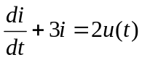,

find i(t) for t > 0 given that i(0) = 0.

